**GIT Lab**

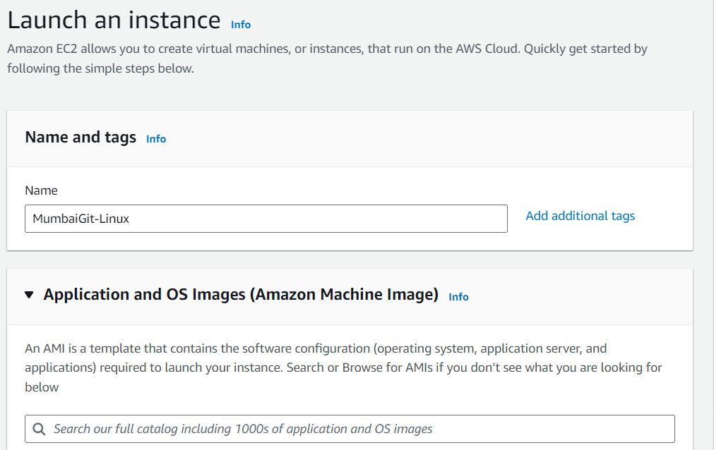

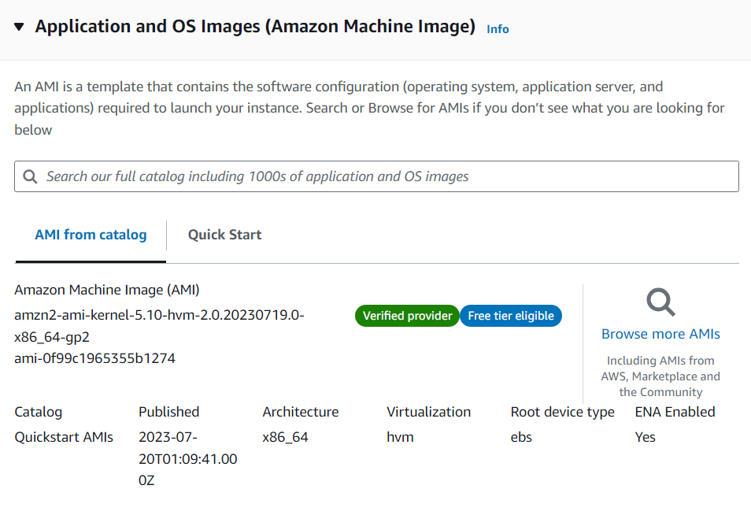

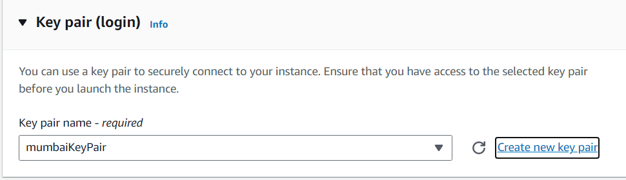

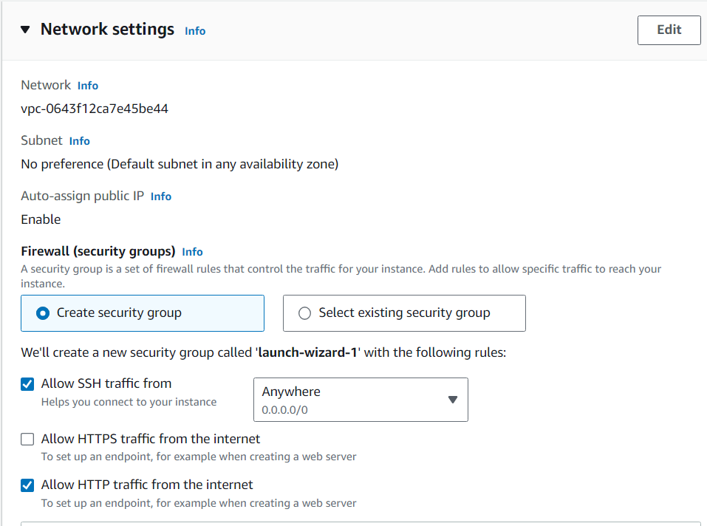

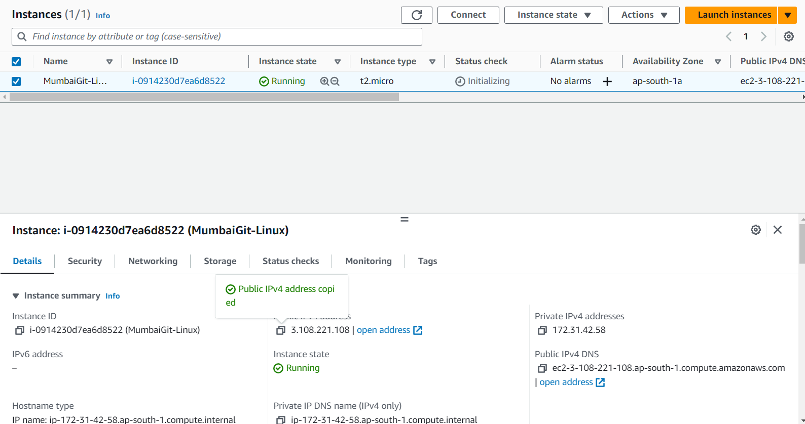

Public IP address for Connecting : 3.108.221.108

login as: ec2-user

[ec2-user@ip-172-31-42-58 ~]$ sudo su

[root@ip-172-31-42-58 ec2-user]# yum update -y

[root@ip-172-31-42-58 ec2-user]# yum install git -y

[root@ip-172-31-42-58 ec2-user]# which git

[root@ip-172-31-42-58 ec2-user]# git --version

[root@ip-172-31-42-58 ec2-user]# git config --global user.name "Employee1"

[root@ip-172-31-42-58 ec2-user]# git config --global user.email "Employee1@company.com"

[root@ip-172-31-42-58 ec2-user]# git config –list

Creating Virginia Instances

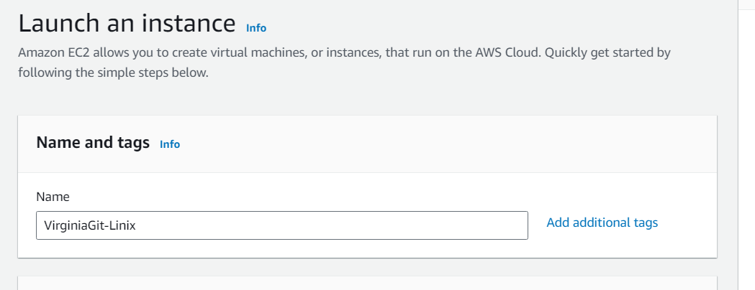

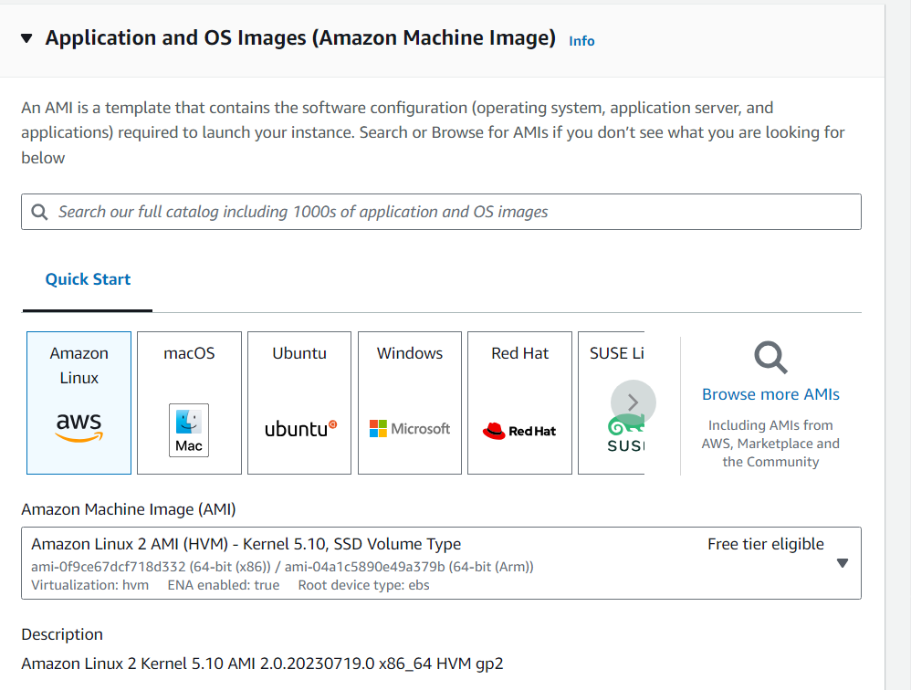

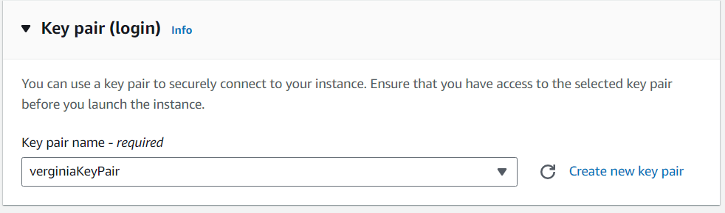

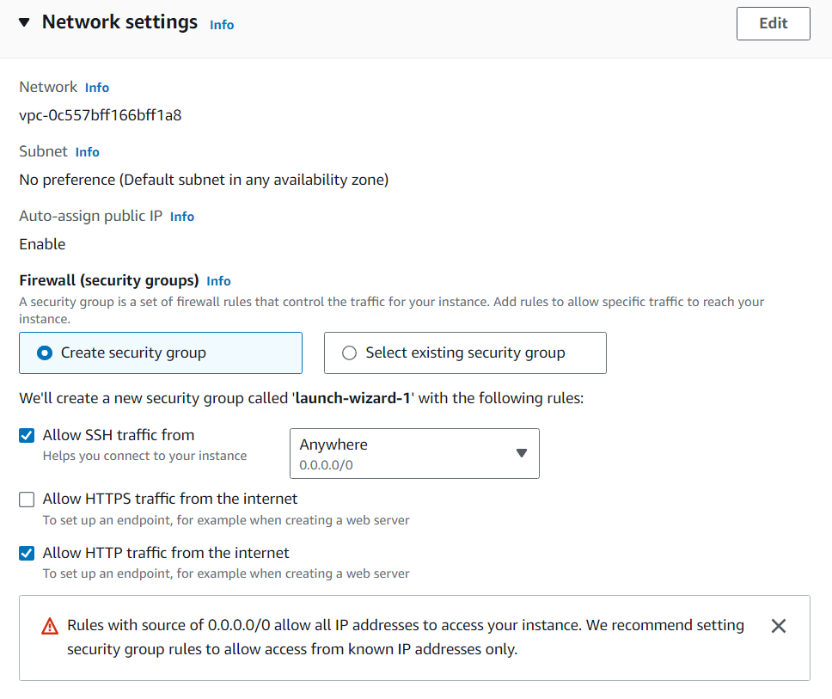

[ec2-user@ip-172-31-81-102 ~]$ sudo su

[root@ip-172-31-81-102 ec2-user]# yum update -y

[root@ip-172-31-81-102 ec2-user]# yum install git -y

[root@ip-172-31-81-102 ec2-user]# git --version

[root@ip-172-31-81-102 ec2-user]# git config --global user.name "Employee2"

[root@ip-172-31-81-102 ec2-user]# git config --global user.email "Employee2@company.com"

[root@ip-172-31-81-102 ec2-user]# git config –list

Connect to the Mumbai Instance and run below commands;

Initially I missed running sudo su

[ec2-user@ip-172-31-42-58 ~]$ mkdir mumbaigit

[ec2-user@ip-172-31-42-58 ~]$ ls

[ec2-user@ip-172-31-42-58 ~]$ cd mumbaigit

[ec2-user@ip-172-31-42-58 mumbaigit]$ git init

[ec2-user@ip-172-31-42-58 mumbaigit]$ cat >mumbai1

printf("Hello Mumbai")

[ec2-user@ip-172-31-42-58 mumbaigit]$ cat mumbai1

[ec2-user@ip-172-31-42-58 mumbaigit]$ git status

[ec2-user@ip-172-31-42-58 mumbaigit]$ git add .

[ec2-user@ip-172-31-42-58 mumbaigit]$ git status

[ec2-user@ip-172-31-42-58 mumbaigit]$ git status

[ec2-user@ip-172-31-42-58 mumbaigit]$ git log

[root@ip-172-31-42-58 mumbaigit]# git show 498964ecac01375d6f33df0b49f7f7478afcb537

[root@ip-172-31-42-58 mumbaigit]# git remote add origin https://github.com/nayak22/Devops.git

[root@ip-172-31-42-58 mumbaigit]# git push -u origin master

[root@ip-172-31-42-58 mumbaigit]# cat >>mumbai1

#adding additional lines to the file

print("Added new Line");

[root@ip-172-31-42-58 mumbaigit]# git status

[root@ip-172-31-42-58 mumbaigit]# git add .

[root@ip-172-31-42-58 mumbaigit]# git commit -m "Second Commit from Mumbai Region"

[root@ip-172-31-42-58 mumbaigit]# git status

[root@ip-172-31-42-58 mumbaigit]# git log

[root@ip-172-31-42-58 mumbaigit]# git show 462e4392ee121854d5542029fb7389943aec1fce

[root@ip-172-31-42-58 mumbaigit]# git push -u origin master

Connect to Virginia Instance

[ec2-user@ip-172-31-81-102 ~]$ sudo su

[root@ip-172-31-81-102 ec2-user]# ls

[root@ip-172-31-81-102 ec2-user]# which git

[root@ip-172-31-81-102 ec2-user]# mkdir virginiagit

[root@ip-172-31-81-102 ec2-user]# ls

[root@ip-172-31-81-102 ec2-user]# cd virginiagit

[root@ip-172-31-81-102 virginiagit]# git init

[root@ip-172-31-81-102 virginiagit]# git remote add origin https://github.com/nayak22/Devops.git

[root@ip-172-31-81-102 virginiagit]# git pull origin master

[root@ip-172-31-81-102 virginiagit]# git log

[root@ip-172-31-81-102 virginiagit]# git show 462e4392ee121854d5542029fb7389943aec1fce

[root@ip-172-31-81-102 virginiagit]# cat >>mumbai1

#Adding the lines of code

print("Hello from Virginia Location")

[root@ip-172-31-81-102 virginiagit]# git status

[root@ip-172-31-81-102 virginiagit]# git add .

[root@ip-172-31-81-102 virginiagit]# git status

[root@ip-172-31-81-102 virginiagit]# git commit -m "First Commit from Virginia Region"

[root@ip-172-31-81-102 virginiagit]# git log

[root@ip-172-31-81-102 virginiagit]# git show 730c484409d339cefcf6c116f8d5bb783859eaaf

[root@ip-172-31-81-102 virginiagit]# git push origin master

Now connect back to Mumbai instance to validate if these changes are reflecting or not.

[ec2-user@ip-172-31-42-58 ~]$ sudo su

[root@ip-172-31-42-58 ec2-user]# cd mumbaigit

[root@ip-172-31-42-58 mumbaigit]# ls

[root@ip-172-31-42-58 mumbaigit]# git log

[root@ip-172-31-42-58 mumbaigit]# git show 730c484409d339cefcf6c116f8d5bb783859eaaf

Git Ignore demo

[root@ip-172-31-42-58 mumbaigit]# vi .gitignore

Press “I”

Type below:

*.java

*.css

Press “esc” key and type “:wq”

[root@ip-172-31-42-58 mumbaigit]# git status

[root@ip-172-31-42-58 mumbaigit]# git add .

[root@ip-172-31-42-58 mumbaigit]# git status

[root@ip-172-31-42-58 mumbaigit]# git commit -m "adding the git ignore file"

[root@ip-172-31-42-58 mumbaigit]# touch file1.txt file2.txt file3.java file4.css file5.java

[root@ip-172-31-42-58 mumbaigit]# ls

[root@ip-172-31-42-58 mumbaigit]# git status

[root@ip-172-31-42-58 mumbaigit]# git add .

[root@ip-172-31-42-58 mumbaigit]# git status

[root@ip-172-31-42-58 mumbaigit]# git commit -m "added some files and ignoring some"

[root@ip-172-31-42-58 mumbaigit]# git push origin master

Branching, merging, conflict demo

[root@ip-172-31-42-58 mumbaigit]# cat >CoflictDemoFile

This is line1 master branch

[root@ip-172-31-42-58 mumbaigit]# git add .

[root@ip-172-31-42-58 mumbaigit]# git commit -m "conflict demo file from master"

[root@ip-172-31-42-58 mumbaigit]# git checkout branch1

[root@ip-172-31-42-58 mumbaigit]# cat >CoflictDemoFile

This is line1 from branch1 branch

[root@ip-172-31-42-58 mumbaigit]#

[root@ip-172-31-42-58 mumbaigit]# git add .

[root@ip-172-31-42-58 mumbaigit]# git commit -m "conflict demo file from branch1"

[root@ip-172-31-42-58 mumbaigit]# git checkout master

[root@ip-172-31-42-58 mumbaigit]# git merge branch1

[root@ip-172-31-42-58 mumbaigit]# vi CoflictDemoFile

[root@ip-172-31-42-58 mumbaigit]# git status

[root@ip-172-31-42-58 mumbaigit]# git add .

[root@ip-172-31-42-58 mumbaigit]# git commit -m "Resolving the conflict"

[root@ip-172-31-42-58 mumbaigit]# touch stashDemoFile

[root@ip-172-31-42-58 mumbaigit]# git add .

[root@ip-172-31-42-58 mumbaigit]# git commit -m "stashDemoFile commit"

[root@ip-172-31-42-58 mumbaigit]# vi stashDemoFile

Write: First Enhancement

Click “esc”

:wq

[root@ip-172-31-42-58 mumbaigit]# git stash

[root@ip-172-31-42-58 mumbaigit]# vi stashDemoFile

Write: Second Enhancement

Click “esc”

:wq

[root@ip-172-31-42-58 mumbaigit]# git stash

[root@ip-172-31-42-58 mumbaigit]# git stash list

[root@ip-172-31-42-58 mumbaigit]# git stash apply stash@{1}

[root@ip-172-31-42-58 mumbaigit]# git add .

[root@ip-172-31-42-58 mumbaigit]# git commit -m "first Enhancement to be pushed "

[root@ip-172-31-42-58 mumbaigit]# git stash apply stash@{0}

[root@ip-172-31-42-58 mumbaigit]# vi stashDemoFile

Resolved the Stash Conflict

[root@ip-172-31-42-58 mumbaigit]# git add .

[root@ip-172-31-42-58 mumbaigit]# git commit -m "second enhancement "

[root@ip-172-31-42-58 mumbaigit]# git push origin master

[root@ip-172-31-42-58 mumbaigit]# git log –oneline

[root@ip-172-31-42-58 mumbaigit]# git stash clear

[root@ip-172-31-42-58 mumbaigit]# git stash list

[root@ip-172-31-42-58 mumbaigit]# cat >ResetDemoFile

Will reverse the staging

[root@ip-172-31-42-58 mumbaigit]# git add .

[root@ip-172-31-42-58 mumbaigit]# git status

[root@ip-172-31-42-58 mumbaigit]# git reset

[root@ip-172-31-42-58 mumbaigit]# git status

Git revert and tag

[root@ip-172-31-42-58 mumbaigit]# cat >>ReverstDemo

Reverstdemo file for demoing Revert in Git

[root@ip-172-31-42-58 mumbaigit]# git add .

[root@ip-172-31-42-58 mumbaigit]# git commit -m "Commiting the to be reverted changes"

[root@ip-172-31-42-58 mumbaigit]# cat >>ReverstDemo

Adding more lines

[root@ip-172-31-42-58 mumbaigit]# git add .

[root@ip-172-31-42-58 mumbaigit]# git commit -m "Commiting the to be reverted change2"

[root@ip-172-31-42-58 mumbaigit]# git log –oneline

[root@ip-172-31-42-58 mumbaigit]# git revert 23e8937

Opens VI to edit message

[root@ip-172-31-42-58 mumbaigit]# git log –oneline

[root@ip-172-31-42-58 mumbaigit]# touch filex filey filez

[root@ip-172-31-42-58 mumbaigit]# git status

[root@ip-172-31-42-58 mumbaigit]# git clean -n

Would remove filex

Would remove filey

Would remove filez

[root@ip-172-31-42-58 mumbaigit]# git clean -f

Removing filex

Removing filey

Removing filez

[root@ip-172-31-42-58 mumbaigit]# git tag -a important -m "this is reverted version for dev pupose - cleanup " 7583af4

[root@ip-172-31-42-58 mumbaigit]# git tag

important

[root@ip-172-31-42-58 mumbaigit]# git show important

[root@ip-172-31-42-58 mumbaigit]# git tag -d important